**Penn State University**

**School of Electrical Engineering and Computer Science**

**CMPEN221 – Computer Organization and Design**

**Section 001**

**Instructor: Sencun Zhu**

**Final Project Part 2**

**Produced by Hongshuo Wang**

1. 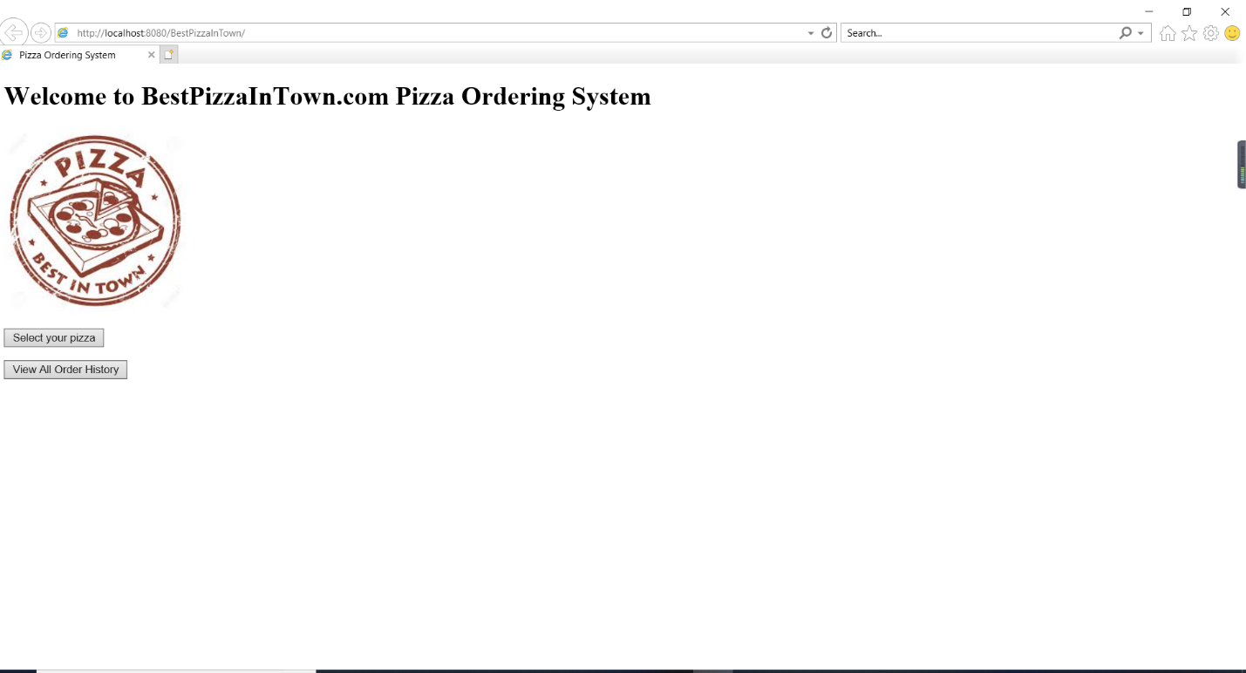The main webpage called index.xhtml
2. 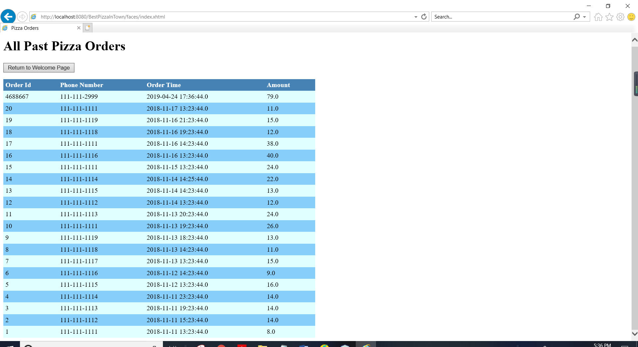The “view all order history” webpage, named orders.xhtml
3. 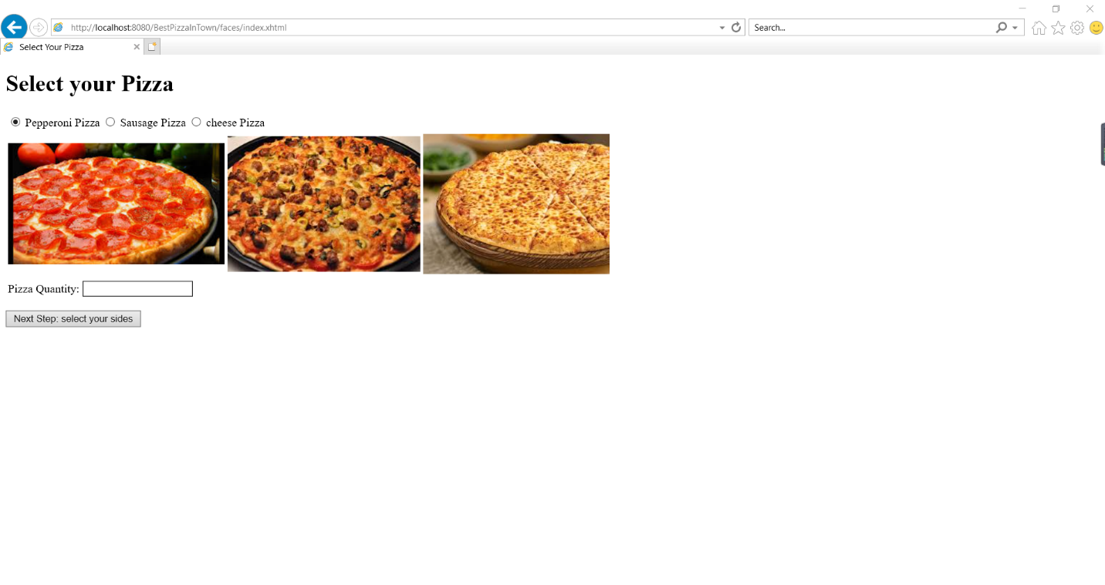The “select your pizza” page, named selectpizza.xhtml
4. 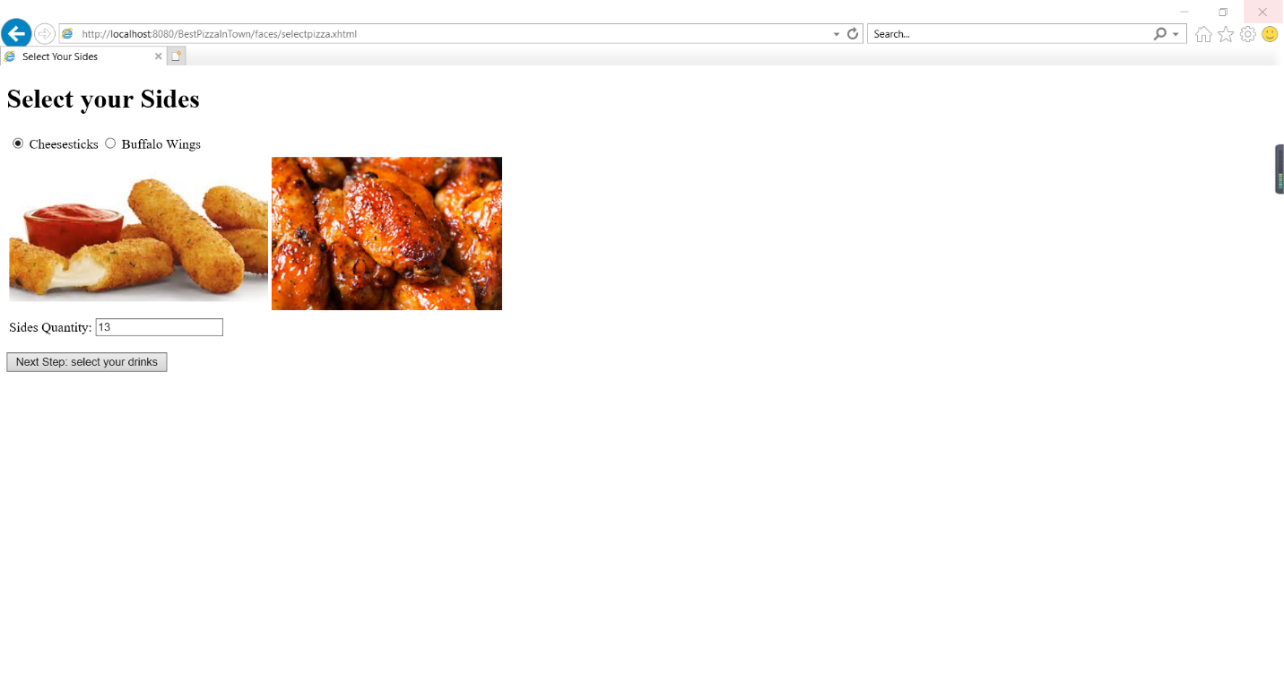The select your sides page, named selectsides.xhtml
5. 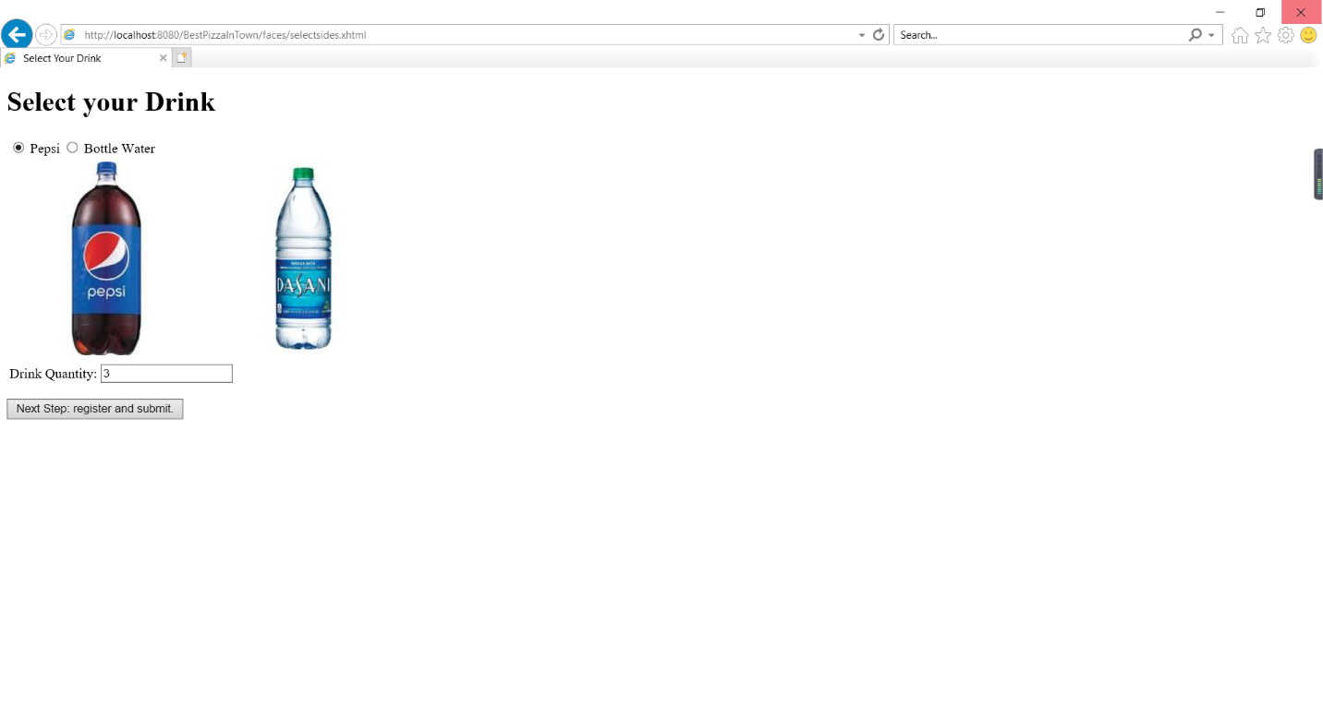The select your drink page, named selectdrink.xhtml
6. 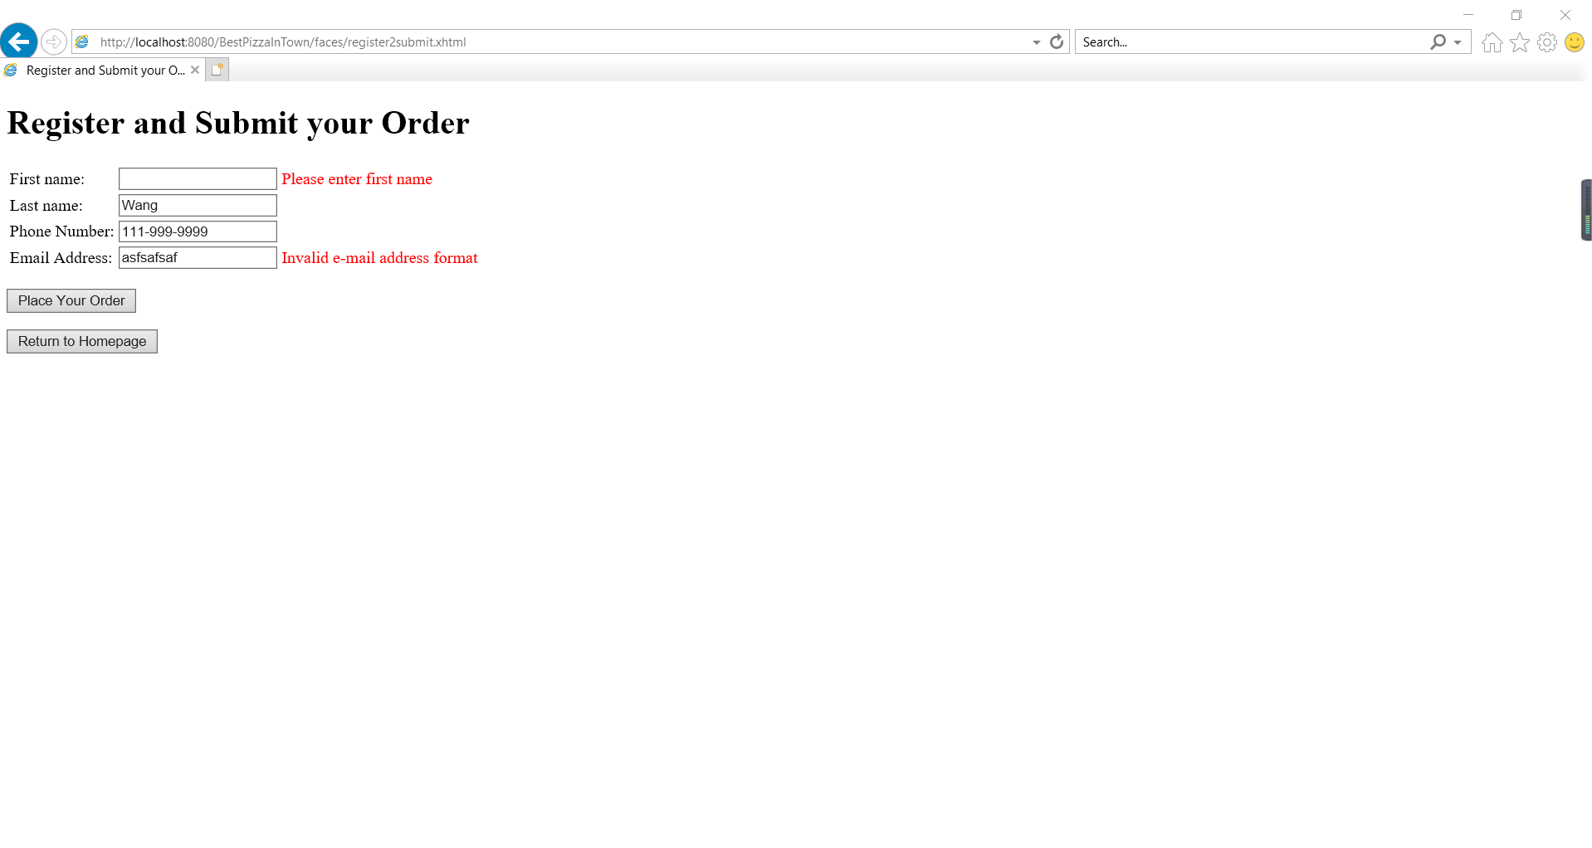The place your order page, named register2submit.xhtml.
7. 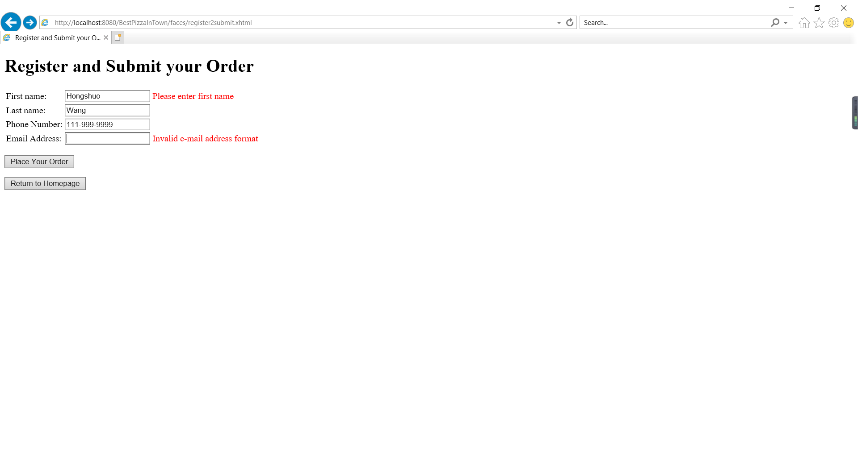Now suppose you enter something like below (it is a new customer)
8. 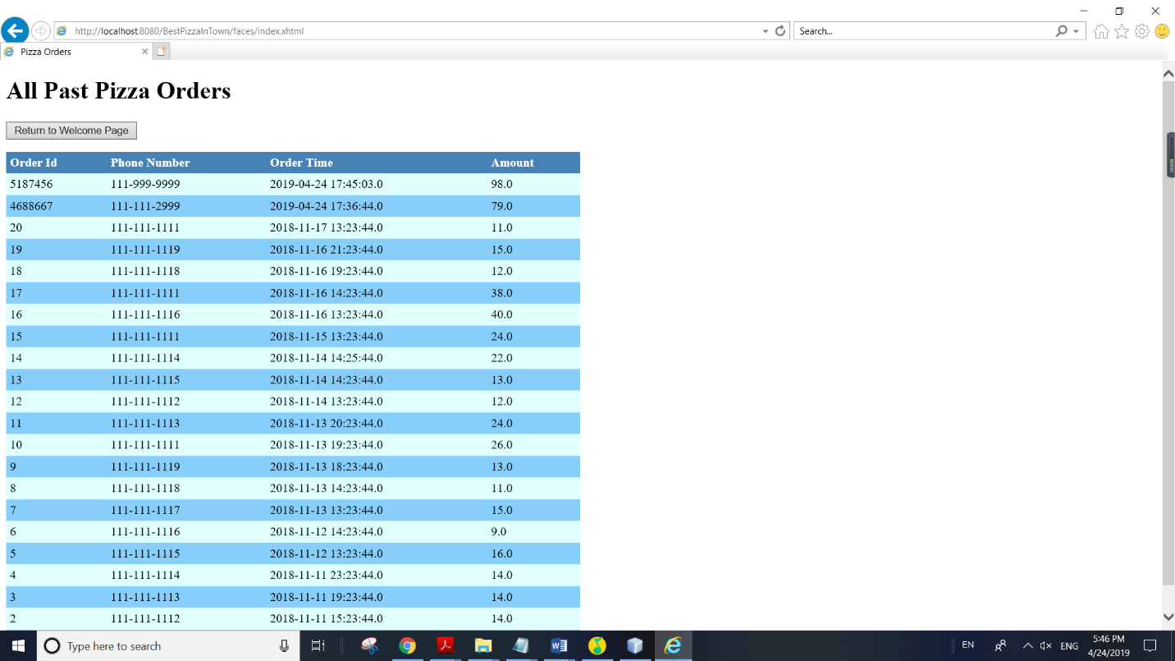After you successfully place your order, you will automatically return to the main page index.xhtml again.